EXPERIMENT 4 : PACKAGES
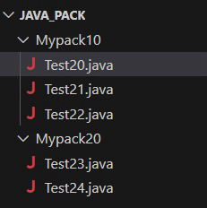
//Test20.java
//Expt4 Creating and Exporting user defined package
package Mypack10; // User Defined package

public class Test20
{
int de = 10;
private int pri = 20;
protected int pro = 30;
public int pub = 40;

void show20()
{
System.out.println("Default de = "+de);
System.out.println("Private pri = "+pri);
System.out.println("Protected pro = "+pro);
System.out.println("Public pub = "+pub);
}

public static void main(String args[])
{
Test20 ob1=new Test20();
ob1.show20();

}
}

OUTPUT:
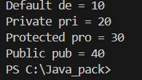
//Test21.java
package Mypack10;
public class Test21 {
void show21()
{
Test20 x=new Test20();
System.out.println("Default de = "+x.de);
//System.out.println("Private pri = "+x.pri);
System.out.println("Protected pro = "+x.pro);
System.out.println("Public pub = "+x.pub);
}

public static void main(String args[])
{
Test21 ob2=new Test21();
ob2.show21();
}

}

OUTPUT:
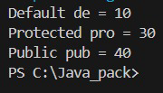
//Test22.java
package Mypack10;

public class Test22 extends Test20{
void show22()
{
System.out.println("Default de = "+de);
//System.out.println("Private pri = "+pri);
System.out.println("Protected pro = "+pro);
System.out.println("Public pub = "+pub);
}

public static void main(String args[])
{
Test22 ob3=new Test22();
ob3.show22();

}
}

OUTPUT:
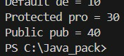

//Test23.java
package Mypack20;
import Mypack10.Test20;
public class Test23 {
void show23()
{
Test20 x=new Test20();
//System.out.println("Default de = "+x.de);
//System.out.println("Private pri = "+x.pri);
//System.out.println("Protected pro = "+x.pro);
System.out.println("Public pub = "+x.pub);
}
public static void main(String args[])
{
Test23 ob4=new Test23();
ob4.show23();
}
}

OUTPUT:
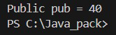
//Test24.java
package Mypack20;

import Mypack10.Test20;

public class Test24 extends Test20 {
void show24()
{
//System.out.println("Default de = "+de);
//System.out.println("Private pri = "+pri);
System.out.println("Protected pro = "+pro);
System.out.println("Public pub = "+pub);
}
public static void main(String args[])
{
Test24 ob5=new Test24();
ob5.show24();
}
}
OUTPUT :
